Pennsylvania Dental Association  2020-2023 Strategic Plan |  | 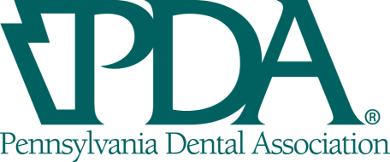
PDA Mission:
The Pennsylvania Dental Association is committed to the success of our members and the advancement of the public’s oral health.
PDA Vision:
Improve oral healthcare through education, advocacy, service and promotion of dentists’ well-being to achieve optimal health for all.

GOAL 1: Membership
Maximize member growth and the member experience.

Objective 1.1 Maintain PDA EOY membership numbers and implement a stretch goal to increase membership by .5% in 2020, with an annual reevaluation of growth goals for future years
Objective 1.2: Provide value offerings that are member-focused
Objective 1.3: Increase member engagement
Objective 1.4: Increase leadership development and engagement

GOAL 2: Financial
Assure organizational sustainability.

Objective 2.1: Non-dues revenue will be 29% of total revenue
Objective 2.2: Reserves will not equal less than 95% of total annual operating budget
Objective 2.3: Streamline current dues structure
Objective 2.4: Achieve and maintain adequate financial resources to execute strategies and tactics associated with the PDA Strategic Plan.

GOAL 3: Organizational
Ensure structure and capacity is sufficient to meet member needs

Objective 3.1: Ensure role clarification is defined for leaders and staff and that capacity is aligned for coordinated execution of the PDA Strategic Plan.
Objective 3.2: Enhance state and local society alignment to better serve members.
Objective 3.3: Ensure decisions are driven by the strategic plan and that the majority of the plan has been implemented by 2023.

GOAL 4: Public
Support the advancement of the health of the public and the success of the profession

Objective 4.1: PDA will be the recognized and trusted voice of oral health information for the public and the profession.
Objective 4.2: PDA will be the recognized and trusted source of information for the public and key stakeholders on dental benefit programs with regard to funding and administration.
Objective 4.3: PDA will support programs that highlight the organization’s commitment to the oral
health of the public.

